James Caan

CEO of Hamilton Bradshaw Ltd

The 3 Questions People Always Forget to Ask in an Interview
August 15, 2013
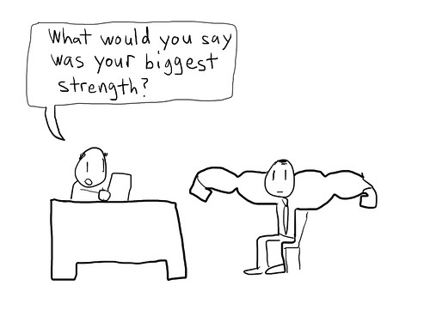
Getting an interview for that dream job is a perfect chance to sell yourself and you need to make sure that you get everything right.
Preparation is vital and it goes without saying that you should turn up for the interview knowing everything there is to know about your prospective employers and the role that you have applied for.
Of course, no two interviews are ever the same and the line of questions that you take will be determined by the nature of the company and the people who are interviewing you.
But I have always been more impressed by candidates who ask ME questions. The process should never be one sided - you need to take control. The best way of doing this is to ask as many questions as the interviewer does.
There are at least three questions you should definitely have ready to ask for every job interview you go for. Remember the aim is to sell yourself as a bright, motivated and ambitious individual but it is important not to be too obvious. The people who are interviewing you will have heard it all before and they will be looking for someone who has that little bit extra quality or personality which sets them apart from the rest of the crowd.
Here are three questions that you should always try and ask:
What qualities are you looking for in the person you are hoping to appoint?
This may sound like a very obvious starting point but it is vital for both parties to grasp exactly what it is needed from candidate in terms of skills and experience. Remember the whole point of the interview is to prove you are the person that they want and are looking for. There is a much better chance of being able to do that if you actually ask the interviewers straight from the start what their ideal candidate would be.
What scope is there for personal development at your company?
It is important to show any prospective employee that you are the type of person who is ambitious and is looking to move their career forward. No one wants to take on an individual who is going to be content to coast and you need to show that you are not coming along just for an easy ride. Any ambitious and forward thinking company will be looking for like minded individuals. Ask a question which will give you give the chance to show just how driven you are.
Is there anything you have seen in the other people on the shortlist that you have not seen in me?
This is a great question to throw into the mix as the interview is drawing to a natural close. I remember a candidate asking me this once and I had to smile because it left me with nowhere to go. As well as turning the tables on the panel it is also a great way of gauging just how well or how badly you have performed throughout the course of the selection process. You should always be looking to improve and getting feedback from an interviewer is a crucial part of this. It is a risky strategy to take because you might get an answer you are not happy with. But if you are prepared to take a risk, then this final question is a gamble that just might pay off.
Keep up to date with all the latest news, jobs and videos at Hamilton Bradshaw.
Photo: Courtesy mysteryapplicant.com

